Remote Start Control Function – CGEA1.3

Functional Description

The Remote Start system enables our customers to start the vehicle from up to 100 meters or more of distance away from the vehicle via a remote control device to help pre-condition the vehicle cabin before entering.

Using the Message Center Switches and Display, the customer can:
- Standard Menu Structure
  - Enable or disable the system and select the duration of operation from 5, 10, or 15 minutes via the message center.
  - Enable or Disable Quiet Start (No Horn/Chirp when remote start).
  - Manipulate Remote Start Climate Control settings (if equipped) for:
    - Front Defrost (Auto, Off).
    - Rear Defrost (Auto, Off). (This menu available per DE00 config)
    - Driver Seat (Auto, Off). (This menu available per DE00 config)
    - Passenger Seat (Auto, Off). (This menu available per DE00 config)
    - Climate Control (Auto, Off/Last Settings). (This menu available per DE00 config)
    - Steering Wheel (Auto Heated, Off). (This menu available per DE00 config)
- Simplified Menu Structure
  - Enable or disable the system and select the duration of operation from 5, 10, or 15 minutes via the message center.
  - Manipulate Remote Start Climate Control settings (if equipped) for:
    - Climate Control (Auto, Last Settings) (Includes Heater-A/C, Front Defrost, Rear Defrost)
    - Seats and Wheel (Auto, Off) (Includes Driver Seat, Passenger Seat, and Steering Wheel)

Note: Only option 1a (above) is applicable to P473. Options 1b and 1c are not supported on P473. Intent is to transition programs to the Simplified Menu starting with CD4.1 M3 IPC, followed by M2 IPC in MY13, then eventually M1 and M0.

Starting in MY2019 with U625/U611 the Settings are migrating from the cluster to Center stack. This STSS supports displaying settings in the cluster or configuring the cluster settings off if they are displayed in the Center stack.

Remote Start Control Function is displayed only in the Message Center while it is in the appropriate SETUP display. See Message Center X Display_Y Button Interface Section, where X and Y are appropriate values in this document for details on when this display is active.

Interfaces

Interface Context Diagram (I/O Block Diagram)
Figure 1: Remote Start Function Context Diagram
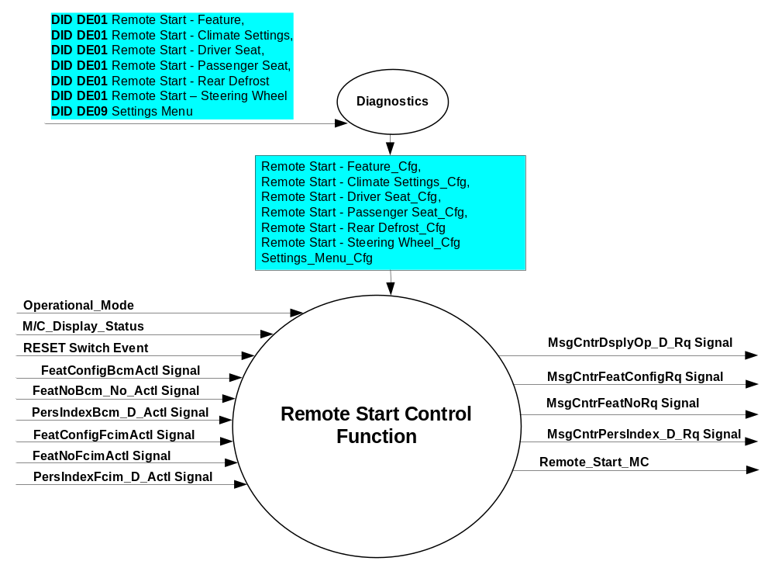

Inputs

- INTERNAL:
- Operational_Mode
- RESET Switch Event
- Remote Start - Feature_Cfg
- Remote Start – Climate Settings_Cfg
- Remote Start – Driver Seat_Cfg
- Remote Start – Passenger Seat_Cfg
- Remote Start – Rear Defrost_Cfg
- Remote Start – Steering Wheel_Cfg
- Settings_Menu_Cfg
- M/C_Display_Status
- MUX message on the CAN Bus from BCM

- FeatConfigBcmActl Signal
Signal Name | Size (bits) | Detail | Units | Res. | Offset | State Encoded | Min | Max
FeatConfigBcmActl | 16 | - | Undefined | 1 | 0 |  | 0  (0x0) | 65535  (0xFFFF)

- FeatNoBcm_No_Actl Signal
Signal Name | Size (bits) | Detail | Units | Res. | Offset | State  Encoded | Min | Max
FeatNoBcm_No_Actl | 16 | - | Number | 1 | 0 |  | 0  (0x0) | 65535  (0xFFFF)

- PersIndexBcm_D_Actl Signal
Signal Name | Size  (bits) | Detail | Units | Res. | Offset | State Encoded | Min | Max
PersIndexBcm_D_Actl | 3 |  | SED | 1 | 0 |  | 0  (0x0) | 7  (0x7)
 |  | PERS_1 |  |  |  | 0 (0x0)
 |  | PERS_2 |  |  |  | 1 (0x1)
 |  | PERS_3 |  |  |  | 2 (0x2)
 |  | PERS_4 |  |  |  | 3 (0x3)
 |  | Vehicle |  |  |  | 4 (0x4)
 |  | Unused |  |  |  | 5(0x5)
 |  | Unused |  |  |  | 6 (0x6)
 |  | Unused |  |  |  | 7 (0x7)

- FeatConfigHvacActl Signal
Signal Name | Size (bits) | Detail | Units | Res. | Offset | State Encoded | Min | Max
FeatConfigFcimActl* | 16 | - | Undefined | 1 | 0 |  | 0  (0x0) | 65535  (0xFFFF)
* Note: This signal is FeatConfigHvacActl in CGEA 1.2. They are equivalent signals. Use whichever one is defined on your program.

- FeatNoHvacActl Signal
Signal Name | Size (bits) | Detail | Units | Res. | Offset | State  Encoded | Min | Max
FeatNoFcimActl* | 16 | - | Number | 1 | 0 |  | 0  (0x0) | 65535  (0xFFFF)

* Note: This signal is FeatNoHvacActl in CGEA 1.2. They are equivalent signals. Use whichever one is defined on your program.

- PersIndexHvac_D_Actl Signal*
Signal Name | Size (bits) | Detail | Units | Res. | Offset | State Encoded | Min | Max
PersIndexFcim_D_Actl** | 3 |  | SED | 1 | 0 |  | 0  (0x0) | 7  (0x7)
 |  | PERS_1 |  |  |  | 0 (0x0)
 |  | PERS_2 |  |  |  | 1 (0x1)
 |  | PERS_3 |  |  |  | 2 (0x2)
 |  | PERS_4 |  |  |  | 3 (0x3)
 |  | Vehicle |  |  |  | 4 (0x4)
 |  | Unused |  |  |  | 5(0x5)
 |  | Unused |  |  |  | 6 (0x6)
 |  | Unused |  |  |  | 7 (0x7)
* Note: This signal is optional. If undefined on a program, then value is always Vehicle (0x4).

** Note: This signal is PersIndexHvac_D_Actl in CGEA 1.2. They are equivalent signals. Use whichever one is defined on your program.

Outputs
- RS_DURATION_MC
- RS_FT_DEFROST_MC
- RS_RT_DEFROST_MC
- RS_DRV_HC_SEAT_MC
- RS_PSG_HC_SEAT_MC
- RS_CLIMATE_CTRL_MC
- RS_QUIET_ST_MC
- RS_STEERING_WHEEL_MC
- MUX message on the CAN Bus

- Message 0x3E0
Message Name | Transmitter | Message Identifier | DLC | TX Model | Period (ms)
_Personality_IPC_Data | IPC_CGEA | 0x3E0 | 8 | Event Periodic | 1000

- MsgCntrDsplyOp_D_Rq Signal
Signal Name | Size (bits) | Detail | Units | Res. | Offset | State Encoded | Min | Max
MsgCntrDsplyOp_D_Rq | 3 |  | SED | 1 | 0 |  | 0  (0x0) | 7  (0x7)
 |  | NULL |  |  |  | 0 (0x0)
 |  | QUERY |  |  |  | 1 (0x1)
 |  | SET |  |  |  | 2 (0x2)
 |  | UPLOAD |  |  |  | 3 (0x3)
 |  | RESTORE |  |  |  | 4 (0x4)
 |  | COPY |  |  |  | 5(0x5)
 |  | Not used |  |  |  | 6 (0x6)
 |  | Not Used |  |  |  | 7 (0x7)
.
- MsgCntrFeatConfigRq Signal
Signal Name | Size (bits) | Detail | Units | Res. | Offset | State  Encoded | Min | Max
MsgCntrFeatConfigRq | 16 |  | Undefined | 1 | 0 |  | 0  (0x0) | 65535  (0xFFFF)

- MsgCntrFeatNoRq Signal
Signal Name | Size (bits) | Detail | Units | Res. | Offset | State  Encoded | Min | Max
MsgCntrFeatNoRq | 16 |  | Number | 1 | 0 |  | 0  (0x0) | 65535  (0xFFFF)

- MsgCntrPersIndex_D_Rq Signal
Signal Name | Size (bits) | Detail | Units | Res. | Offset | State Encoded | Min | Max
MsgCntrPersIndex_D_Rq | 3 |  | SED | 1 | 0 |  | 0  (0x0) | 7  (0x7)
 |  | PERS_1 |  |  |  | 0 (0x0)
 |  | PERS_2 |  |  |  | 1 (0x1)
 |  | PERS_3 |  |  |  | 2 (0x2)
 |  | PERS_4 |  |  |  | 3 (0x3)
 |  | Vehicle |  |  |  | 4 (0x4)
 |  | Not Used |  |  |  | 5(0x5)
 |  | Not Used |  |  |  | 6 (0x6)
 |  | Not Used |  |  |  | 7 (0x7)

Function/Performance

Operational Modes

Mode | Differentiating Vehicle Conditions
Sleep Mode | Remote Start Text Message Disabled
Limited Mode | Remote Start Text Message Disabled
Normal Mode | Remote Start Text Message Enabled / Disabled  - ability to change the Remote Start settings
Crank Mode | Remote Start Text Message Enabled / Disabled  - ability to change the Remote Start settings

Voltage Levels

Refer to the Cluster Features table located in the Operational Modes and Voltage Range Strategies Section in this SPSS.

Human-Machine Interface

Visual

Indicator Graphics / Display Format
For High End Display (SHMI), refer to “<Program> Cluster Menu Structure.xls” and Program VAPS Model.
U38x graphics:
Menu level 3 | Menu level 4 |  | Menu level 5 |  | Menu level 6
Remote Start | Climate Control |  | Heater - A/C | ☑ | Auto (default setting)
Remote Start | Climate Control |  |  | ◻ | Last Settings
Remote Start | Climate Control |  | Steering Wheel | ☑ | Auto (default setting)
Remote Start | Climate Control |  |  | ◻ | Off
Remote Start | Climate Control |  | Front Defrost | ☑ | Auto (default setting)
Remote Start | Climate Control |  |  | ◻ | Off
Remote Start | Climate Control |  | Rear Defrost | ☑ | Auto (default setting)
Remote Start | Climate Control |  |  | ◻ | Off
Remote Start | Climate Control |  | Driver Seat | ☑ | Auto (default setting)
Remote Start | Climate Control |  |  | ◻ | Off
Remote Start | Climate Control |  | Passenger Seat | ☑ | Auto (default setting)
Remote Start | Climate Control |  |  | ◻ | Off
Remote Start | Duration | ◻ | 5 minutes
Remote Start | Duration | ☑ | 10 minutes (default setting)
Remote Start | Duration | ◻ | 15 minutes
Remote Start | Quiet Start | ◻ | On
Remote Start | Quiet Start | ☑ | Off (default setting)
Remote Start | Restore Default |  | Hold OK to Restore Remote Start to Factory Default
Remote Start | System | ☑ | Enable (default setting)
Remote Start | System | ◻ | Disable

Another Typical example. Note that "System On/Off" is part of "Duration"
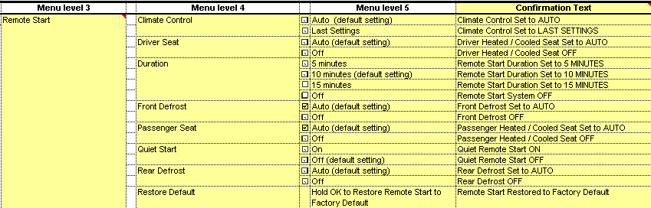

For B Display, refer to Message Center Function description reference "B Display 2x14 Text Message List.xls"– Message ID SU705, SU710, SU720, SU730, and SU740.

Example of Simplified Menu:

Menu level 2 | Menu level 3 |  | Menu level 4
Remote Start | Climate Control | ◉ | Auto (default setting)
Remote Start | Climate Control | ○ | Last Settings
Remote Start | Seats and Wheel  (or "Seats" if no heated steering wheel) | ◉ | Auto (default setting)
Remote Start | Seats and Wheel  (or "Seats" if no heated steering wheel) | ○ | Off
Remote Start | Duration | ○ | 5 minutes
Remote Start | Duration | ◉ | 10 minutes (default setting)
Remote Start | Duration | ○ | 15 minutes
Remote Start | ☑ System

Indicator Color Coordinates

Reference section COLOR & ILLUMINATION REQUIREMENTS (GRAPHICS)

Indicator Characteristics

Refer to Message Center X Display_Y Button Interface Section, where X and Y are appropriate values in this document.

Audio

None

Switch Control Logic

Consumer access to the Remote Start Configuration shall be as specified in the message center basic functionality display as specified in Message Center X Display_Y Button Interface Section, where X and Y are appropriate values in this document.

System Accuracy

Within a 150msec of receiving a message that results in a change of state the cluster will update the display to the proper status.

Operation: Performance and Functional

Subsystem Algorithm Flowchart / State Diagram

Figure 2: Remote Start Diagnostic Configuration Flowcharts

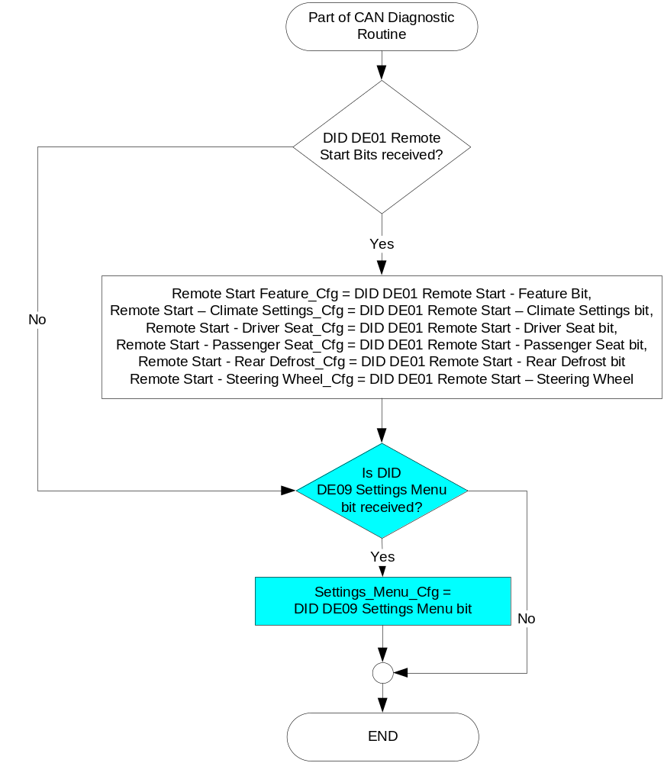

Figure 3: Remote Start output SET request Flowchart
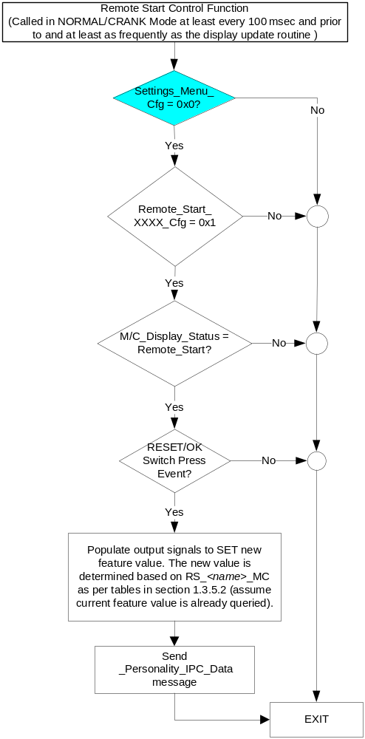

NOTES:
- In the Remote Start Control Function Flowchart, the definition of "RESET Switch Event" is defined in Message Center X Display_Y Button Interface Section, where X and Y are appropriate values in this document.
- "XXXX" is the corresponding Remote Start DE00 configuration bit (i.e. Remote Start - Feature_Cfg, Remote Start – Climate Settings_Cfg, Remote Start – Driver Seat_Cfg, Remote Start – Passenger Seat_Cfg, Remote Start – Rear Defrost_Cfg, Remote Start – Steering Wheel_Cfg).
- When multiple features are being set at the same time, as in the case of simplified menus, SET commands for the group of features should be sent in quick succession, ~ 50-100 ms apart. SET commands should only be sent for features with an Enabled configuration.

Operation Description (supports algorithm flowchart /state diagram)

- Remote Start – Driver Heat/Cool Seat (Not applicable to P473)
FeatNoFcimActl or  FeatNoHvacActl | FeatConfigFcimActl or FeatConfigHvacActl | PersIndexFcim_D_Actl or PersIndexHvac_D_Actl | RS_DRV_HC_SEAT_MC | Current_PERS ⁽³⁾
0x501 ⁽¹⁾ | 0x0000 (Auto) | 0x0 – 0x4 | 0x00 | 0x0 – 0x4
0x501 ⁽¹⁾ | 0x0001 (Off) | 0x0 – 0x4 | 0x01 | 0x0 – 0x4
0x501 ⁽¹⁾ | Other ⁽²⁾ |  | Not Supported (0x4) | Last known
Missing per Section 1.4.1 ⁽²⁾ |  |  | Error  (0x4) | Last Known
⁽¹⁾ Remote Start Driver Seat Feature Number. Reference is Feat Num table in “Vehicle Personalization FS”
⁽²⁾ Message Response is Faulted
⁽³⁾ Equal to the received “PersIndex<--->” signal value. When faulted Keep last known value.

- Remote Start – Passenger Heat/Cool Seat (Not applicable to P473)
FeatNoFcimActl or FeatNoHvacActl | FeatConfigFcimActl or FeatConfigHvacActl | PersIndexFcim_D_Actl or PersIndexHvac_D_Actl | RS_PSG_HC_SEAT_MC | Current_PERS ⁽³⁾
0x502 ⁽¹⁾ | 0x0000 (Auto) | 0x0 – 0x4 | 0x00 | 0x0 – 0x4
0x502 ⁽¹⁾ | 0x0001 (Off) | 0x0 – 0x4 | 0x01 | 0x0 – 0x4
0x502 ⁽¹⁾ | Other ⁽²⁾ |  | Not Supported (0x4) | Last known
Missing per Section 1.4.1 ⁽²⁾ |  |  | Error  (0x4) | Last Known
⁽¹⁾ Remote Start Passenger Seat Feature Number. Reference is Feat Num table in “Vehicle Personalization FS”
⁽²⁾ Message Response is Faulted
⁽³⁾ Equal to the received “PersIndex<--->” signal value. When faulted Keep last known value.

- Remote Start – Front Defrost (Not applicable to P473)
FeatNoFcimActl or FeatNoHvacActl | FeatConfigFcimActl or FeatConfigHvacActl |  | PersIndexFcim_D_Actl or PersIndexHvac_D_Actl |  | RS_FT_DEFROST_MC | Current_PERS ⁽³⁾
0x503 ⁽¹⁾ |  | 0x0000 (Off) |  | 0x0 – 0x4 | 0x00 | 0x0 – 0x4
 |  | 0x0001 (Auto) |  | 0x0 – 0x4 | 0x01 | 0x0 – 0x4
 |  | Other ⁽²⁾ |  |  | Not Supported (0x4) | Last known
Missing per Section 1.4.1 ⁽²⁾ |  |  |  |  | Error  (0x4) | Last Known
⁽¹⁾ Remote Start Front Defrost Feature Number. Reference is Feat Num table in “Vehicle Personalization FS”
⁽²⁾ Message Response is Faulted
⁽³⁾ Equal to the received “PersIndex<--->” signal value. When faulted Keep last known value.

- Remote Start – Rear Defrost (Not applicable to P473)
FeatNoFcimActl or FeatNoHvacActl | FeatConfigFcimActl or FeatConfigHvacActl | PersIndexFcim_D_Actl or PersIndexHvac_D_Actl | RS_RR_DEFROST_MC | Current_PERS ⁽³⁾
0x504 ⁽¹⁾ | 0x0000 (Off) | 0x0 – 0x4 | 0x00 | 0x0 – 0x4
0x504 ⁽¹⁾ | 0x0001 (Auto) | 0x0 – 0x4 | 0x01 | 0x0 – 0x4
0x504 ⁽¹⁾ | Other ⁽²⁾ |  | Not Supported (0x4) | Last known
Missing per Section 1.4.1 ⁽²⁾ |  |  | Error  (0x4) | Last Known
⁽¹⁾ Remote Start Rear Defrost Feature Number. Reference is Feat Num table in “Vehicle Personalization FS”
⁽²⁾ Message Response is Faulted
⁽³⁾ Equal to the received “PersIndex<--->” signal value. When faulted Keep last known value.

- Remote Start – Quiet Start (Not applicable to P473)
FeatNoFcimActl or FeatNoHvacActl | FeatConfigFcimActl or FeatConfigHvacActl | PersIndexFcim_D_Actl or PersIndexHvac_D_Actl | RS_QUIET_ST_MC | Current_PERS ⁽³⁾
0x505 ⁽¹⁾ | 0x0000 (Off) | 0x0 – 0x4 | 0x00 | 0x0 – 0x4
0x505 ⁽¹⁾ | 0x0001 (On) | 0x0 – 0x4 | 0x01 | 0x0 – 0x4
0x505 ⁽¹⁾ | Other ⁽²⁾ |  | Not Supported (0x4) | Last known
Missing per Section 1.4.1 ⁽²⁾ |  |  | Error  (0x4) | Last Known
⁽¹⁾ Remote Start Quiet Start Feature Number. Reference is Feat Num table in “Vehicle Personalization FS”
⁽²⁾ Message Response is Faulted
⁽³⁾ Equal to the received “PersIndex<--->” signal value. When faulted Keep last known value.

- Remote Start – Climate control - Heater A/C (Not applicable to P473)
FeatNoFcimActl or FeatNoHvacActl | FeatConfigFcimActl or FeatConfigHvacActl | PersIndexFcim_D_Actl or PersIndexHvac_D_Actl | RS_CLIMATE_CTRL_MC | Current_PERS ⁽³⁾
0x509 ⁽¹⁾ | 0x0000 (Auto) | 0x0 – 0x4 | 0x00 | 0x0 – 0x4
0x509 ⁽¹⁾ | 0x0001 (Last Settings) | 0x0 – 0x4 | 0x01 | 0x0 – 0x4
0x509 ⁽¹⁾ | Other ⁽²⁾ |  | Not Supported (0x4) | Last known
Missing per Section 1.4.1 ⁽²⁾ |  |  | Error  (0x4) | Last Known
⁽¹⁾ Remote Start Climate Control Feature Number. Reference is Feat Num table in “Vehicle Personalization FS”
⁽²⁾ Message Response is Faulted
⁽³⁾ Equal to the received “PersIndex<--->” signal value. When faulted Keep last known value.

- Remote Start - Duration State Assignment
FeatNoBcm_No_Actl | FeatConfigBcmActl | PersIndexBcm_D_Actl | RS_DURATION_MC |  | Current_PERS ⁽³⁾
0x406 ⁽¹⁾ | 0x0000 | 0x0 – 0x4 |  | 0x00 | 0x0 – 0x4
0x406 ⁽¹⁾ | 0x0001 | 0x0 – 0x4 |  | 0x01 | 0x0 – 0x4
0x406 ⁽¹⁾ | 0x0002 | 0x0 – 0x4 |  | 0x02 | 0x0 – 0x4
0x406 ⁽¹⁾ | 0x0003 | 0x0 – 0x4 |  | 0x03 | 0x0 – 0x4
0x406 ⁽¹⁾ | Other ⁽²⁾ |  |  | 0x04 (Error) | Last Known
Missing per Section 1.4.1 ⁽²⁾ |  |  |  | 0x04 (Error) | Last Known
⁽¹⁾ Remote Start Duration Feature Number. Reference is Feat Num table in “Vehicle Personalization FS”
⁽²⁾ Message Response is Faulted
⁽³⁾ Equal to the received “PersIndex<--->” signal value. When faulted Keep last known value.
- Remote Start – Steering Wheel (Not applicable to P473)
FeatNoFcimActl or FeatNoHvacActl | FeatConfigFcimActl or FeatConfigHvacActl | PersIndexFcim_D_Actl or PersIndexHvac_D_Actl | RS_STEERING_WHEEL_MC | Current_PERS ⁽³⁾
0x40A ⁽¹⁾ | 0x0000 (Auto) | 0x0 – 0x4 | 0x00 | 0x0 – 0x4
0x40A ⁽¹⁾ | 0x0001 (Off) | 0x0 – 0x4 | 0x01 | 0x0 – 0x4
0x40A ⁽¹⁾ | Other ⁽²⁾ |  | Not Supported (0x4) | Last known
Missing per Section 1.4.1 ⁽²⁾ |  |  | Error (0x4) | Last Known
⁽¹⁾ Remote Start Quiet Start Feature Number. Reference is Feat Num table in “Vehicle Personalization FS”
⁽²⁾ Message Response is Faulted
⁽³⁾ Equal to the received “PersIndex<--->” signal value. When faulted Keep last known value.

- Message Center Display and Remote Start – Duration Request Messages

based upon RS_DURATION_MC
RS_DURATION_MC | MC Display  MSG. ID: SU710/SU720 | MsgCntrDsplyOp_D_Rq  Signal | MsgCntrFeatNoRq  Signal | MsgCntrFeatConfigRq  Signal | MsgCntrPersIndex_D_Rq  Signal
0x00 | REMOTE START  ON <OFF> | SET (0x2) | 0x406 | 0x0002  (Msg. ID = SU710) | Current_PERS
0x1 – 0x3 | REMOTE START  <ON> OFF | SET (0x2) | 0x406 | 0x0000  (Msg. ID = SU710) * | Current_PERS
0x04 | REMOTE START  ON OFF | SET (0x2) | 0x406 | 0x0002  (Msg. ID = SU710) | Current_PERS
0x01 | REMOTE START  <5> 10 15 MIN | SET (0x2) | 0x406 | 0x0002  (Msg. ID= SU720) | Current_PERS
0x02 | REMOTE START  5 <10> 15 MIN | SET (0x2) | 0x406 | 0x0003  (Msg. ID = SU720) | Current_PERS
0x03 | REMOTE START  5 10 <15> MIN | SET (0x2) | 0x406 | 0x0001  (Msg. ID = SU720) | Current_PERS
0x4 | REMOTE START  5 10 15 MIN | SET (0x2) | 0x406 | 0x0002  (Msg. ID = SU720) | Current_PERS
Notes:
- If Remote Start is Disabled, all subsequent RS Displays (Message ID. SU720, SU730, and SU740) will be disabled (Skipped).
- Remote Start - Feature_Cfg must be Enabled to display this menu

- High End Display and Duration Request Messages with "System On/Off" as part of "Duration"

based upon RS_DURATION_MC – Standard and Simplified Menu
RS_DURATION_MC | Display Menu | 5-Button Switch Selection Event | MsgCntrDsply  Op_D_Rq  Signal | MsgCntrFeat  NoRq  Signal | MsgCntrFeatConfig  Rq  Signal | MsgCntrPers  Index_D_Rq  Signal
0x00 | 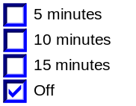 | Up/Down + OK (Select 5, 10, or 15 minutes) | SET (0x2) | 0x406 | 0x0001 (if 5 minutes is Selected)  0x0002 (if 10 minutes Selected)  0x0003 (if 15 minutes Selected) | Current_PERS
0x01 | 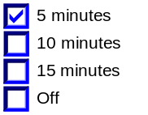 | Up/Down + OK (Select 10 or 15 minutes or OFF) | SET (0x2) | 0x406 | 0x0000 (if Off is Selected)  0x0002 (if 10 minutes Selected)  0x0003 (if 15 minutes Selected) | Current_PERS
0x02 | 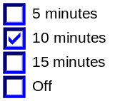 | Up/Down + OK (Select 5 or 15 minutes or OFF) | SET (0x2) | 0x406 | 0x0000 (if Off is Selected)  0x0001 (if 5 minutes is Selected)  0x0003 (if 15 minutes Selected) | Current_PERS
0x03 | 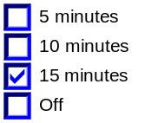 | Up/Down + OK (Select 5 or 10 minutes or OFF) | SET (0x2) | 0x406 | 0x0000 (if Off is Selected)  0x0001 (if 5 minutes is Selected)  0x0002 (if 10 minutes Selected) | Current_PERS
0x4 | 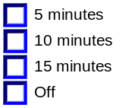 | Up/Down + OK (Select Any) | SET (0x2) | 0x406 | 0x0000 (if Off is Selected)  0x0001 (if 5 minutes is Selected)  0x0002 (if 10 minutes Selected)  0x0003 (if 15 minutes Selected) | Current_PERS
Note: Remote Start - Feature_Cfg must be Enabled to display this menu

- High End Display and System Enable/Disable Messages based upon RS_DURATION_MC

(Applicable to U38x, not applicable to P473) – Standard and Simplified Menu
RS_DURATION_MC | Display Menu  (System and Durration) | 5-Button Switch Selection Event | MsgCntrDsply  Op_D_Rq  Signal | MsgCntrFeat  NoRq  Signal | MsgCntrFeatConfig  Rq  Signal | MsgCntrPers  Index_D_Rq  Signal
0x00 | 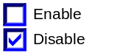 | Up/Down + OK (Select Enable) | SET (0x2) | 0x406 | 0x0002 (if Enabled is Selected) | Current_PERS
0x01 – 0x03 | 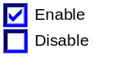 | Up/Down + OK (Select Disable) | SET (0x2) | 0x406 | 0x0000 (if Disable is Selected) | Current_PERS
0x04 | 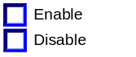 | Up/Down + OK (Select ANY) | SET (0x2) | 0x406 | 0x0000 (if Disable is Selected)  0x0002 (if Enabled is Selected) | Current_PERS
0x01 | 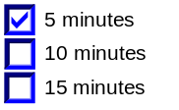 | Up/Down + OK (Select 10 or 15 minutes) | SET (0x2) | 0x406 | 0x0002 (if 10 minutes Selected)  0x0003 (if 15 minutes Selected) | Current_PERS
0x02 | 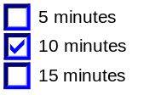 | Up/Down + OK (Select 5 or 15 minutes) | SET (0x2) | 0x406 | 0x0001 (if 5 minutes is Selected)  0x0003 (if 15 minutes Selected) | Current_PERS
0x03 | 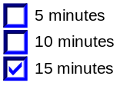 | Up/Down + OK (Select 5 or 10 minutes) | SET (0x2) | 0x406 | 0x0001 (if 5 minutes is Selected)  0x0002 (if 10 minutes Selected) | Current_PERS
0x4 | 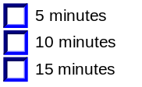 | Up/Down + OK (Select Any) | SET (0x2) | 0x406 | 0x0001 (if 5 minutes is Selected)  0x0002 (if 10 minutes Selected)  0x0003 (if 15 minutes Selected) | Current_PERS
Note: Remote Start - Feature_Cfg must be Enabled to display this menu

- Message Center Display and Climate control Request Messages

based upon RS_CLIMATE_CTRL_MC (Not applicable to P473) – Standard Menu
RS_CLIMATE_CTRL_MC | MC Display  MSG. ID: SU730 | MsgCntrDsplyOp_D_Rq  Signal | MsgCntrFeatNoRq  Signal * | MsgCntrFeatConfigRq  Signal | MsgCntrPersIndex_D_Rq  Signal
0x00 | REMOTE START  TEMP AUTO <OFF> | SET (0x2) | 0x503 and 0x504 | 0x0001 | Current_PERS
0x00 | REMOTE START  TEMP AUTO <OFF> | SET (0x2) | 0x501, 0x502, and 0x509 | 0x0000 | Current_PERS
0x01 | REMOTE START  TEMP <AUTO> OFF | SET (0x2) | 0x503 and 0x504 | 0x0000 | Current_PERS
0x01 | REMOTE START  TEMP <AUTO> OFF | SET (0x2) | 0x501, 0x502, and 0x509 | 0x0001 | Current_PERS
0x04 | REMOTE START  TEMP AUTO OFF | SET (0x2) | 0x503, 0x504 | 0x0001 | Current_PERS
0x04 | REMOTE START  TEMP AUTO OFF | SET (0x2) | 0x501, 0x502, and 0x509 | 0x0000 | Current_PERS
Note: Remote Start - Feature_Cfg AND Remote Start – Climate Settings_Cfg must be Enabled to display this menu

* When “AUTO” or “OFF” is selected using Reset button on a B-display and message ID SU730 is present, a series of SET requests with the selected value (AUTO or OFF) will be initiated for the following features:
- Front Defrost (ID 0x503)
- Rear Defrost (ID 0x504)
- Driver Seat (ID 0x501)
- Passenger Seat (ID 0x502)
- Climate Control (ID 0x509)
- Steering Wheel (ID 0x40A)

If any of the above feature IDs is received, the response will be accepted and appropriate selection (AUTO/OFF) in MSG. ID SU730 will be displayed.

- High End Display and Front Defrost Request Messages

based upon RS_FT_DEFROST_MC (Not applicable to P473) – Standard Menu Only
RS_FT_DEFROST_MC | Display Menu  “Front Defrost” | 5-Button Switch Selection Event | MsgCntrDsplyOp_D_Rq  Signal | MsgCntrFeatNoRq  Signal | MsgCntrFeatConfigRq  Signal | MsgCntrPersIndex_D_Rq  Signal
0x00 | 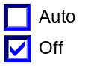 | Up/Down + OK (Select Auto) | SET (0x2) | 0x503 | 0x0001 | Current_PERS
0x01 | 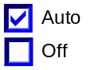 | Up/Down + OK (Select Off) | SET (0x2) | 0x503 | 0x0000 | Current_PERS
0x4 | 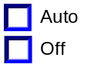 | Up/Down + OK (Select Any) | SET (0x2) | 0x503 | 0x0000 – 0x0001  (Based on Selection) | Current_PERS
Note: Remote Start - Feature_Cfg must be Enabled to display this menu

- High End Display and Rear Defrost Request Messages

based upon RS_RR_DEFROST_MC (Not applicable to P473) – Standard Menu Only
RS_RR_DEFROST_MC | Display Menu  “Rear Defrost” | 5-Button Switch Selection Event | MsgCntrDsplyOp_D_Rq  Signal | MsgCntrFeatNoRq  Signal | MsgCntrFeatConfigRq  Signal | MsgCntrPersIndex_D_Rq  Signal
0x00 |  | Up/Down + OK (Select Auto) | SET (0x2) | 0x504 | 0x0001 | Current_PERS
0x01 |  | Up/Down + OK (Select Off) | SET (0x2) | 0x504 | 0x0000 | Current_PERS
0x4 |  | Up/Down + OK (Select Any) | SET (0x2) | 0x504 | 0x0000 – 0x0001  (Based on Selection) | Current_PERS
Note: Remote Start - Feature_Cfg AND Remote Start – Rear Defrost_Cfg must be Enabled to display this menu

- High End Display and Climate control Request Messages

based upon RS_CLIMATE_CTRL_MC (Not applicable to P473) – Standard Menu Only
RS_CLIMATE_CTRL_MC | Display Menu  “Climate Control” | 5-Button Switch Selection Event | MsgCntrDsplyOp_D_Rq  Signal | MsgCntrFeatNoRq  Signal | MsgCntrFeatConfigRq  Signal | MsgCntrPersIndex_D_Rq  Signal
0x00 | 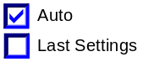 | Up/Down + OK (Select Last Settings) | SET (0x2) | 0x509 | 0x0001 | Current_PERS
0x01 | 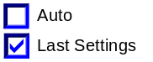 | Up/Down + OK (Select Auto) | SET (0x2) | 0x509 | 0x0000 | Current_PERS
0x4 | 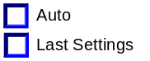 | Up/Down + OK (Select Any) | SET (0x2) | 0x509 | 0x0000 – 0x0001  (Based on Selection) | Current_PERS
Note: Remote Start - Feature_Cfg must be Enabled to display this menu

- High End Display and Climate control Request Messages

based upon RS_CLIMATE_CTRL_MC (Not applicable to P473) – Simplified Menu Only
RS_CLIMATE_CTRL_MC | Display Menu  “Climate Control” | 5-Button Switch Selection Event | MsgCntrDsplyOp_D_Rq  Signal | MsgCntrFeatNoRq  Signal* | MsgCntrFeatConfigRq  Signal | MsgCntrPersIndex_D_Rq  Signal
0x00 |  | Up/Down + OK (Select Last Settings) | SET (0x2) | 0x509 (Heater A/C)  0x503 (Front Defrost)  0x504 (Rear Defrost) | 0x0001 (Last Setting)  0x0001 (Auto)  0x0001 (Auto) | Current_PERS
0x01 |  | Up/Down + OK (Select Auto) | SET (0x2) | 0x509 (Heater A/C)  0x503 (Front Defrost)  0x504 (Rear Defrost) | 0x0000 (Auto)  0x0001 (Auto)  0x0001 (Auto) | Current_PERS
0x4 |  | Up/Down + OK (Select Any) | SET (0x2) | 0x509 (Heater A/C)  0x503 (Front Defrost)  0x504 (Rear Defrost) | 0x0000 – 0x0001  (Based on Selection) | Current_PERS
Note: Remote Start - Feature_Cfg must be Enabled to display this menu. SET command should be sent only for features that have an Enabled configuration bit.

* When “AUTO” or “Last Settings” is selected using OK button on Climate Control menu, a series of SET requests with the selected value (AUTO or Last Setting) will be initiated for the following features in order:
- Climate Control (ID 0x509)
- Front Defrost (ID 0x503)
- Rear Defrost (ID 0x504)

As soon as Climate Control (ID 0x509) is received, the response will be accepted and appropriate selection (AUTO/Last Setting) in menu will be displayed.

- High End Display and Driver Seat Request Messages

based upon RS_DRV_HC_SEAT_MC (Not applicable to P473) – Standard Menu Only
RS_DRV_HC_SEAT_MC | Display Menu  “Driver Seat” | 5-Button Switch Selection Event | MsgCntrDsplyOp_D_Rq  Signal | MsgCntrFeatNoRq  Signal | MsgCntrFeatConfigRq  (HS CAN) | MsgCntrPersIndex_D_Rq  Signal
0x00 |  | Up/Down + OK (Select Off) | SET (0x2) | 0x501 | 0x0001 | Current_PERS
0x01 |  | Up/Down + OK (Select Auto) | SET (0x2) | 0x501 | 0x0000 | Current_PERS
0x4 |  | Up/Down + OK (Select Any) | SET (0x2) | 0x501 | 0x0000 – 0x0001  (Based on Selection) | Current_PERS
Note: Remote Start - Feature_Cfg AND Remote Start – Driver Seat_Cfg must be Enabled to display this menu

- High End Display and Passenger Seat Request Messages

based upon RS_PSG_HC_SEAT_MC (Not applicable to P473) – Standard Menu Only
RS_PSG_HC_SEAT_MC | Display Menu  “Passenger Seat” | 5-Button Switch Selection Event | MsgCntrDsply  Op_D_Rq  Signal | MsgCntrFeatNoRq  Signal | MsgCntrFeatConfigRq  Signal | MsgCntrPersIndex_D_Rq  Signal
0x00 |  | Up/Down + OK (Select Off) | SET (0x2) | 0x502 | 0x0001 | Current_PERS
0x01 |  | Up/Down + OK (Select Auto) | SET (0x2) | 0x502 | 0x0000 | Current_PERS
0x4 |  | Up/Down + OK (Select Any) | SET (0x2) | 0x502 | 0x0000 – 0x0001  (Based on Selection) | Current_PERS
Note: Remote Start - Feature_Cfg AND Remote Start – Passenger Seat_Cfg must be Enabled to display this menu

- High End Display and Steering Wheel Request Messages

based upon RS_STEERING_WHEEL_MC (Not applicable to P473) – Standard Menu Only
RS_STEERING  _WHEEL_MC | Display Menu  “Steering Wheel” | 5-Button Switch Selection Event | MsgCntrDsply  Op_D_Rq  Signal | MsgCntrFeatNoRq  Signal | MsgCntrFeatConfigRq  Signal | MsgCntrPersIndex  _D_Rq Signal
0x00 | 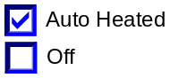 | Up/Down + OK (Select Off) | SET (0x2) | 0x40A | 0x0001 | Current_PERS
0x01 | 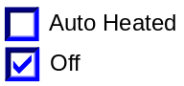 | Up/Down + OK (Select On) | SET (0x2) | 0x40A | 0x0000 | Current_PERS
0x4 | 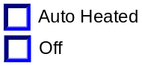 | Up/Down + OK (Select Any) | SET (0x2) | 0x40A | 0x0000 – 0x0001  (Based on Selection) | Current_PERS
Note: Remote Start - Feature_Cfg and RS_Steering_Wheel_Cfg must both be Enabled to display this menu

- High End Display and Seats and Wheel Messages

based upon RS_DRV_HC_SEAT_MC (Not applicable to P473) – Simplified Menu Only
RS_DRV_HC_SEAT_MC | Display Menu  "Seats" or “Seats and Steering Wheel” | 5-Button Switch Selection Event | MsgCntrDsply  Op_D_Rq  Signal | MsgCntrFeatNoRq  Signal* | MsgCntrFeatConfigRq  Signal | MsgCntrPersIndex  _D_Rq Signal
0x00 |  | Up/Down + OK (Select Off) | SET (0x2) | 0x501 (Driver Seat)  0x502 (Passenger Seat)  0x40A (Steering Wheel) | 0x0001 | Current_PERS
0x01 |  | Up/Down + OK (Select On) | SET (0x2) | 0x501 (Driver Seat)  0x502 (Passenger Seat)  0x40A (Steering Wheel) | 0x0000 | Current_PERS
0x4 |  | Up/Down + OK (Select Any) | SET (0x2) | 0x501 (Driver Seat)  0x502 (Passenger Seat)  0x40A (Steering Wheel) | 0x0000 – 0x0001  (Based on Selection) | Current_PERS
Note: Remote Start - Feature_Cfg and Remote Start – Driver Seat_Cfg must be Enabled to display this menu. SET command should be sent only for features that have an Enabled configuration bit.
In the Simplified Menu, seats and steering wheel setting will follow the Driver's Seat.

* When “Auto Heated” or “Off” is selected using OK button on Seats menu, a series of SET requests with the selected value (0x0 or 0x1) will be initiated for the following features in order:
- Driver Seat (ID 0x501)
- Passenger Seat (ID 0x502)
- Steering Wheel (ID 0x40A)

As soon as Driver Seat (ID 0x501) is received, the response will be accepted and appropriate selection (Auto Heated/Off) in menu will be displayed.

- High End Display and Quiet Start Request Messages

based upon RS_QUIET_ST_MC (Not applicable to P473) – Standard Menu Only
RS_QUIET_ST_MC | Display Menu  “Quiet Start” | 5-Button Switch Selection Event | MsgCntrDsplyOp_D_Rq  Signal | MsgCntrFeatNoRq  Signal | MsgCntrFeatConfigRq  Signal | MsgCntrPersIndex_D_Rq  Signal
0x00 | 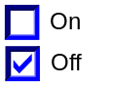 | Up/Down + OK (Select On) | SET (0x2) | 0x505 | 0x0001 | Current_PERS
0x01 | 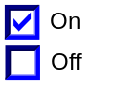 | Up/Down + OK (Select Off) | SET (0x2) | 0x505 | 0x0000 | Current_PERS
0x4 | 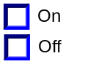 | Up/Down + OK (Select Any) | SET (0x2) | 0x505 | 0x0000 – 0x0001  (Based on Selection) | Current_PERS
Note: Remote Start - Feature_Cfg must be Enabled to display this menu

- Message Center Display and Quiet Start Request Messages

based upon RS_QUIET_ST_MC (Not applicable to P473) – Standard Menu Only
RS_QUIET_ST_MC | MC Display  MSG. ID: SU740 | MsgCntrDsplyOp_D_Rq  Signal | MsgCntrFeatNoRq  Signal | MsgCntrFeatConfigRq  Signal | MsgCntrPersIndex_D_Rq  Signal
0x00 | REMOTE START  QUIET ON <OFF> | SET (0x2) | 0x505 | 0x0001 | Current_PERS
0x01 | REMOTE START  QUIET <ON> OFF | SET (0x2) | 0x505 | 0x0000 | Current_PERS
0x4 | REMOTE START  QUIET ON OFF | SET (0x2) | 0x505 | 0x0000 | Current_PERS
Note: Remote Start - Feature_Cfg must be Enabled to display this menu

- Remote Start “Restore Default” Request Messages (Not applicable to P473) – Standard Menu Only
High End Display  “Restore Default” | 5-Button Switch Selection Event | MsgCntrDsplyOp_D_Rq  Signal | MsgCntrFeatNoRq  Signal * | MsgCntrFeatConfigRq  Signal | MsgCntrPersIndex_D_Rq  Signal
Hold OK to Restore Restore Remote Start to Factory Default | (OK is Selected) | SET (0x2) | 0x406 | 0x2 (10 minutes) | Current_PERS
Hold OK to Restore Restore Remote Start to Factory Default | (OK is Selected) | SET (0x2) | 0x40A | 0x0 (auto) | Current_PERS
Hold OK to Restore Restore Remote Start to Factory Default | (OK is Selected) | SET (0x2) | 0x501 | 0x0 (auto) | Current_PERS
Hold OK to Restore Restore Remote Start to Factory Default | (OK is Selected) | SET (0x2) | 0x502 | 0x0 (auto) | Current_PERS
Hold OK to Restore Restore Remote Start to Factory Default | (OK is Selected) | SET (0x2) | 0x503 | 0x1 (auto) | Current_PERS
Hold OK to Restore Restore Remote Start to Factory Default | (OK is Selected) | SET (0x2) | 0x504 | 0x1 (auto) | Current_PERS
Hold OK to Restore Restore Remote Start to Factory Default | (OK is Selected) | SET (0x2) | 0x505 | 0x0 (off) | Current_PERS
Hold OK to Restore Restore Remote Start to Factory Default | (OK is Selected) | SET (0x2) | 0x509 | 0x0 (auto) | Current_PERS
Note: Remote Start - Feature_Cfg must be Enabled to display this menu

* When Default values are requested, a series of SET requests with the value shown will be initiated for the following features:
- Front Defrost (ID 0x503) = 0x1
- Rear Defrost (ID 0x504) = 0x1
- Driver Seat (ID 0x501) = 0x0
- Passenger Seat (ID 0x502) = 0x0
- Climate Control (ID 0x509) = 0x0
- Quiet Start (ID 0x505) = 0x0
- Steering Wheel (ID 0x40A) = 0x0
- Duration (ID 0x406) = 0x2

Function Safety Classification (EMC)
Class B

Memory Storage

- Function Parameters
Parameter Name | Description | Value at  Battery Connect | Value at  Wake-up
- RS_DURATION_MC  - RS_FT_DEFROST_MC  - RS_RT_DEFROST_MC  - RS_DRV_HC_SEAT_MC  - RS_PSG_HC_SEAT_MC  - RS_CLIMATE_CTRL_MC  - RS_QUIET_ST_MC  - RS_STEERING_WHEEL_MC | Output(s) displayed in the M/C | 255 (0xFF) | Do Not Init
Current_PERS | Current Personality Profile | PERS_1 (0x0) | Do Not Init
MsgCntrDsplyOp_D_Rq Signal | Output Signal to indicate Request Type. | NULL (0x0) | Do Not Init
MsgCntrFeatNoRq Signal | Output Signal to indicate Feature Number. | (0x0000) | Do Not Init
MsgCntrFeatConfigRq Signal | Output Signal to Specify the desired feature Value. | (0x0000) | Do Not Init
MsgCntrPersIndex_D_Rq Signal | Output Signal to indicate which personality profile is being accessed. | PERS_1 (0x0) | Do Not Init
FeatNoBcm_No_Actl Signal | Input signal sent from BCM to indicate Feature Number. | (0x0000) | Do Not Init
FeatConfigBcmActl Signal | Input signal sent from BCM to indicate current value of the feature setting for the feature that is being set or queried. | (0x0000) | Do Not Init
PersIndexBcm_D_Actl Signal | Input signal sent from BCM to indicate which personality profile is being reported. | PERS_1 (0x0) | Do Not Init
Remote_Start - Feature_Cfg | State indicator for feature presence controlled via CAN at EOL at VO plant. Set to disabled at Cluster Supplier Manufacturing Plant | Use Stored Value | Use Stored Value
Remote Start – Climate Settings_Cfg | State indicator for feature presence controlled via CAN at EOL at VO plant. Set to disabled at Cluster Supplier Manufacturing Plant | Use Stored Value | Use Stored Value
Remote Start – Driver Seat_Cfg | State indicator for feature presence controlled via CAN at EOL at VO plant. Set to disabled at Cluster Supplier Manufacturing Plant | Use Stored Value | Use Stored Value
Remote Start – Passenger Seat_Cfg | State indicator for feature presence controlled via CAN at EOL at VO plant. Set to disabled at Cluster Supplier Manufacturing Plant | Use Stored Value | Use Stored Value
Remote Start – Rear Defrost_Cfg | State indicator for feature presence controlled via CAN at EOL at VO plant. Set to disabled at Cluster Supplier Manufacturing Plant | Use Stored Value | Use Stored Value
Remote Start – Steering_Wheel_Cfg | State indicator for feature presence controlled via CAN at EOL at VO plant. Set to disabled at Cluster Supplier Manufacturing Plant | Use Stored Value | Use Stored Value
Settings_Menu_Cfg | Configures cluster to display items in the Settings menu (Set to “cluster” at cluster supplier manufacturer plant) | Use Stored Value | Use Stored Value
M/C_Display_Status | State Indicator to identify which text is currently being displayed on Message Center display. See * | See * | See*
RESET Switch Event | Event that is indicated as per the switch interface for the Message Center. See * | See * | See*
Operational_Mode | 4 state indicator for cluster operational mode | Limited | Limited, Normal or Crank
* Refer to Message Center X Display_Y Button Interface Section, where X and Y are appropriate values in this document.

Reconfigurable Telltale

Not Applicable

Prove Out

Not applicable

Message Center Msg

Refer to Message Center Function description reference "Text Message List - BEF Displays 2x14.xls" file -- Message ID SU705, SU710, SU720, SU730, and SU740.

Error Handling

Missing Message Strategy

The signals will be declared missing as per the Diagnostics section of this SPSS.

DTCs states and history will be determined as per the Diagnostics section of this SPSS.

If Remote_Start_Cfg = Disabled, the cluster shall never log a missing message DTC for this feature.

Diagnostics

Self Test

None

Engineering Test Mode

Reference section “Dealer / Engineering Test Mode (ETM)”

Part II Performance

Supported Diagnostic Trouble Codes (DTCs)
DTC | Description
C14000 | Lost of Communication with CGEA_HS_BCM

DID DExx
Block  Num | Block Description | Byte(s) | Bits | State: Description | "0" | "1" | Default | Comments/  Information
PACKETED BLOCKS
$01 | Option Content (B&A) | * | * | Remote Start - Feature | Disabled | Enabled | Disabled | This parameter allows the Remote Start settings menu to be displayed in the cluster. It can be over-ridden by the Settings Menu config. IF THE SETTINGS MENU CFG IS SET TO “CENTER STACK”, THEN DISABLE THIS PARAMETER.  When Enabled, High end cluster displays a minimum of :  1. Duration  2. Quiet Start  3. Front Defrost  4. Restore Default  5. System (U38x) or Activate Remote Start
$01 | Option Content (B&A) | * | * | Remote Start – Climate Settings | Disabled | Enabled | Disabled | Set bit the same as “Remote Start – Feature” above.  When Remote Start Feature and this bit is Enabled, cluster also displays:  6. Climate Control Settings
$01 | Option Content (B&A) | * | * | Remote Start – Driver Seat | Disabled | Enabled | Disabled | When Remote Start Feature and this bit is Enabled, cluster also displays:  7. Driver Seat
$01 | Option Content (B&A) | * | * | Remote Start – Passenger Seat | Disabled | Enabled | Disabled | When Remote Start Feature and this bit is Enabled, cluster also displays:  8. Passenger Seat
$01 | Option Content (B&A) | * | * | Remote Start – Rear Defrost | Disabled | Enabled | Disabled | When Remote Start Feature and this bit is Enabled, cluster also displays:  9. Rear Defrost
$01 | Option Content (B&A) | * | * | Remote Start – Steering Wheel | Disabled | Enabled | Disabled | When Remote Start Feature and this bit is Enabled, cluster also displays:  10. Steering Wheel (Seats and Wheels in simplified menu)
$09 | Option Content (B&A) | * | * | Settings Menu | Cluster | Center Stack | Cluster | This parameter allows the Settings menu to be displayed in the cluster when 0x0. When 0x1, the expectation is that settings are displayed in the Centerstack. For this feature (when 0x1), the cluster will remove almost all items from settings menu. (Cluster display choices remain). Note this is a global config, each feature still has its own config for presence on vehicle.
*Byte and bit location to be identified in Part II Specification for this cluster

Reference Specification

None

Revision History
SPSS Module Revision History

Revision Level | Name | Change Description | Date
1.0 | V. Patel | Updated for CGEA 1.3 based on CGEA STSS v5.3  Section 1.2.2 – Removed table referencing the HS-CAN message that contains the input signal.  Section 1.2.3 – Removed table referencing the HS-CAN message that contains the output signal.  Section 1.2 – Deleted “Position” column from the input and output signal tables.  Section 1.4 – Rewritten. Deleted references of specific missing message flags and timer.  Section 1.5.3 – Deleted DTC logging criteria from the table. | 4/22/2010
1.1 | S. Watkins | Since vehicles are now set to Personalization setting “Vehicle (0x4)”, the use of the PersIndex…_D_Actl signals is optional. On CD4, the signal PersIndexHvac_D_Actl is undefined. Therefore, I made a note below Table 1.5 that this signal is optional, and to use 0x4 always if the signal is undefined on a program. | 1/19/2011
2.0 | J.Gregoire | Updates support the menu simplification effort for IPC.  Section 1.1 – Updated to include Simplified Menu.  Section 1.3.3.2 – Added example of Simplified Menu for IPC  Figure 1.3 – Added Note 3 regarding simplified menus.  Section 1.3.5.2 – Re-ordered tables and added which menu (Standard and/or Simplified Menu) the table represents.  Table 1.26 – Added for Simplified Menu of Climate Control settings.  Table 1.30 – Added for Simplified Menu of Seats and Wheel settings. | 2/13/2012
2.1 | S. Watkins | Name change necessary for CAN input signals. This is a name change only.  Signals "FeatConfigHvacActl, FeatNoHvacActl, and PersIndexHvac_D_Actl" has been changed to " FeatConfigFcimActl, FeatNoFcimActl, and PersIndexFcim_D_Actl".  - STSS updated throughout to accept either HVAC or FCIM signals on a given program. | 6/6/2012
3.0 | S. Watkins | On 2016 U502, when implementing Table 1.26, it was found that not all suppliers update the radio button as soon as the first response to the SET command is received. This was due to the requirement being below Table 1.22. Thus, in theory this STSS update does not change any requirements, its purpose is to make the requirements much clearer for the case where multiple SET commands are issued.  - Figure 3 – Changed part of Note 3 from 300ms to 100ms.  - Added notes below Table 1.26 and Table 1.30.  - Section 1.5.3 – Did DExx – Updated comment for Remote Start – Climate Settings. | 4/22/2015
3.1 | Deepa B  S. Watkins | No functional changes, only updated HMI Text and typos:  - Spec updated as per QnA IPC_FS550_MY15 #249. Changed “Auto heated” to “Auto” in section 1.3.3.2 Indicator Graphics / Display Format  - Updated Section 1.3.1 to show functionality in Crank.  - Updated Figure 3 in Section 1.3.5.1 to show functionality in Crank.  - Updated DExx to DE01. | 10/2/2016
4.0 | S. Watkins | Starting in MY2019 with U625/U611 the Settings are migrating from the cluster to Centerstack. This STSS update is to support this effort. A configuration is added to ensure backward compatiblity.  Changes shown in blue:  - Section 1.1 – Updated description to mention Center Stack  - Section 1.2.1, Figure 1 – Added DE09 Settings Menu  - Section 1.2.2 – Added Settings_Menu_Cfg  - Section 1.3.5.1, Figure 2 – Added DE09 Settings Menu  - Section 1.3.5.1, Figure 3 – Added decision box for Settings_Menu_Cfg  - Section 1.3.5.4 – Added Settings_Menu_Cfg  - Section 1.5.3 – Added Settings Menu to DE09 and updated comments for other configs. | 1/16/2017

